***The Ten Phases of Systems Development Life Cycle (SDLC)***

The SDLC includes ten phases during which defined IT work products are created or modified. The tenth phase occurs when the system is disposed of and the task performed is either eliminated or transferred to other systems. Not every project will require that the phases be sequentially executed. However, the phases are interdependent. Depending upon the size and complexity of the project, phases may be combined or may overlap.

**1.   Initiation Phase**

The initiation of a system (or project) begins when a business need or opportunity is identified. A Project Manager should be appointed to manage the project. This business need is documented in a Concept Proposal. After the Concept Proposal is approved, the System Concept Development Phase begins.

**2.  System Concept Development Phase**

Once a business need is approved, the approaches for accomplishing the concept are reviewed for feasibility and appropriateness. The Systems Boundary Document identifies the scope of the system and requires Senior Official approval and funding before beginning the Planning Phase.

**3. Planning Phase**

The concept is further developed to describe how the business will operate once the approved system is implemented, and to assess how the system will impact employee and customer privacy. To ensure the products and / or services provide the required capability on-time and within budget, project resources, activities, schedules, tools, and reviews are defined. Additionally, security certification and accreditation activities begin with the identification of system security requirements and the completion of a high level vulnerability assessment.

**4. Requirements Analysis Phase**

Functional user requirements are formally defined and delineate the requirements in terms of data, system performance, security, and maintainability requirements for the system. All requirements are defined to a level of detail sufficient for systems design to proceed. All requirements need to be measurable and testable and relate to the business need or opportunity identified in the Initiation Phase.

**5. Design Phase**

The physical characteristics of the system are designed during this phase. The operating environment is established, major subsystems and their inputs and outputs are defined, and processes are allocated to resources. Everything requiring user input or approval must be documented and reviewed by the user. The physical characteristics of the system are specified and a detailed design is prepared. Subsystems identified during design are used to create a detailed structure of the system. Each subsystem is partitioned into one or more design units or modules. Detailed logic specifications are prepared for each software module.  
[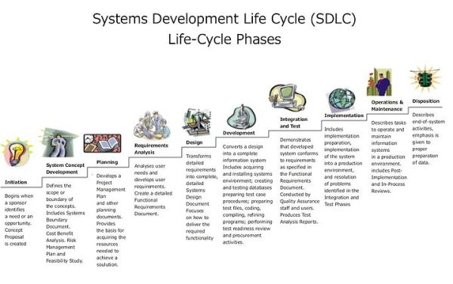](https://ndtechdock.files.wordpress.com/2012/04/systems-development-life-cycle1.jpg)  
**6**. **Development Phase**

The detailed specifications produced during the design phase are translated into hardware, communications, and executable software. Software shall be unit tested, integrated, and retested in a systematic manner. Hardware is assembled and tested.

**7. Integration and Test Phase**

The various components of the system are integrated and systematically tested. The user tests the system to ensure that the functional requirements, as defined in the functional requirements document, are satisfied by the developed or modified system. Prior to installing and operating the system in a production environment, the system must undergo certification and accreditation activities.

**8. Implementation Phase**

The system or system modifications are installed and made operational in a production environment. The phase is initiated after the system has been tested and accepted by the user. This phase continues until the system is operating in production in accordance with the defined user requirements.

**9. Operations and Maintenance Phase**

The system operation is ongoing. The system is monitored for continued performance in accordance with user requirements, and needed system modifications are incorporated. The operational system is periodically assessed through In-Process Reviews to determine how the system can be made more efficient and effective. Operations continue as long as the system can be effectively adapted to respond to an organization’s needs. When modifications or changes are identified as necessary, the system may reenter the planning phase.

**10. Disposition Phase**

The disposition activities ensure the orderly termination of the system and preserve the vital information about the system so that some or all of the information may be reactivated in the future if necessary. Particular emphasis is given to proper preservation of the data processed by the system, so that the data is effectively migrated to another system or archived in accordance with applicable records management regulations and policies, for potential future access.